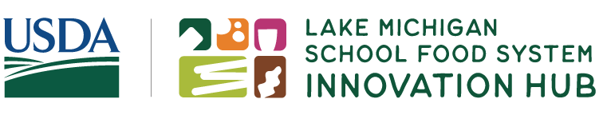
Pre-Launch Webinar: Transforming Ideas into Applications with Lake Michigan’s Food System Innovation Hub.
Objectives: By the end of this webinar, participants will be able to:
- Summarize what Lake Michigan School Food System Innovation Hub is looking to support.
- Navigate the Innovation Hub website.
- Share questions about the Innovation Hub and connect with support for next steps.
Funding Opportunity:
In February 2024, the Lake Michigan School Food System Innovation Hub will open applications for two new funding opportunities: the Spark Awards and the Innovation Collaborative Awards. Additional grant cycles will continue through 2028.

A few ideas I have for projects are…

Potential partners to make it happen…

SPARK AWARDS
Spark Awards fund projects that need a short-term infusion of funds for school food system and marketplace improvements, such as capacity-building, planning, and product testing projects.

Award Range: $10,000 – $75,000
Grant Cycle: One year, with optional 4-month extension period
Project Timeline: Aug. 1, 2024 – Jul. 31, 2025

INNOVATION COLLABORATIVE
AWARDS
Innovation Collaborative Awards fund projects that promote systems-level change of the school food system and marketplace, such as scaling up of programs, regional partnerships, or new program or product development and integration.

Award: $250,000
Grant Cycle: 2.5 years
Project Timeline: Aug. 1, 2024 – Dec. 31, 2026

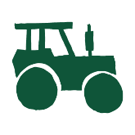
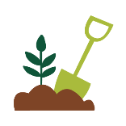
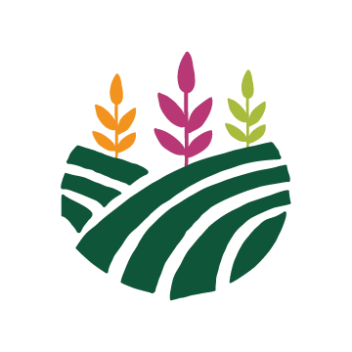
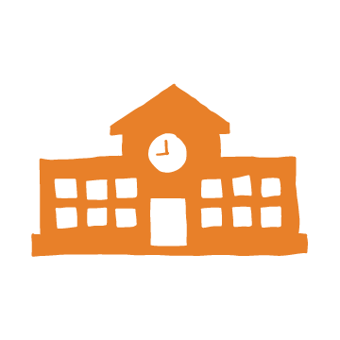
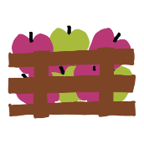
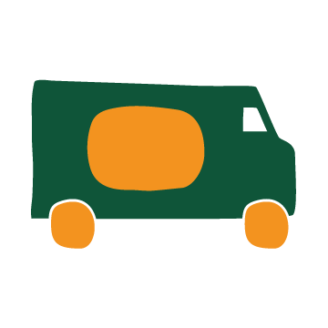
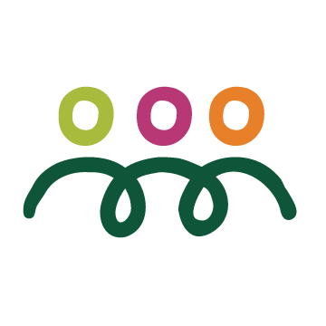

Innovation doesn’t have to mean “first” or “only”.
My ideas are innovative because…

“Community” refers to the group of people who are benefiting from your project. Your project may serve more than one type of community.
My project benefits the following communities…

Who can I collaborate with to better meet the needs of my target community?

Innovation Hub website: https://innovateschoolfood.org/
What I want to check out on the Innovation Hub website…

Support for Applicants: https://innovateschoolfood.org/support/
Questions I would like answered…

My next steps…

Application Opens February 1, 2024!

