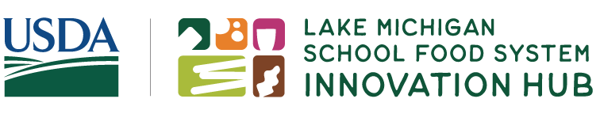
Lake Michigan School Food System Launch Webinar:
Understanding Our Grants and How We Can Help
Objectives: By the end of this webinar, participants will be able to:
- Review Lake Michigan School Food System Innovation Hub request for applications and answers to questions.
- Access support available to help apply.
- Discuss community engagement approaches in the project expectations.
Funding Opportunity:
The Lake Michigan School Food System Innovation Hub has opened applications for Spark and Innovation Collaborative Awards.
How can we use the support resources available to strengthen our application?

SPARK AWARDS
Spark Awards fund projects that need a short-term infusion of funds for school food system and marketplace improvements, such as capacity-building, planning, and product testing projects.

Award Range: $10,000 – $75,000
Grant Cycle: One year, with optional 4-month extension period
Project Timeline: Aug. 1, 2024 – Jul. 31, 2025

INNOVATION COLLABORATIVE
AWARDS
Innovation Collaborative Awards fund projects that promote systems-level change of the school food system and marketplace, such as scaling up of programs, regional partnerships, or new program or product development and integration.

Award: $250,000
Grant Cycle: 2.5 years
Project Timeline: Aug. 1, 2024 – Dec. 31, 2026

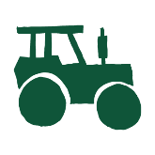
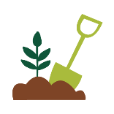
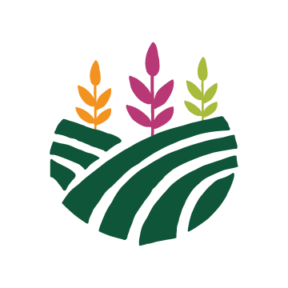
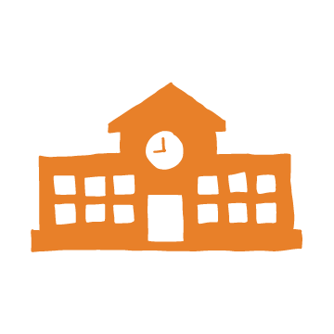
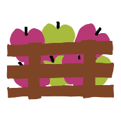
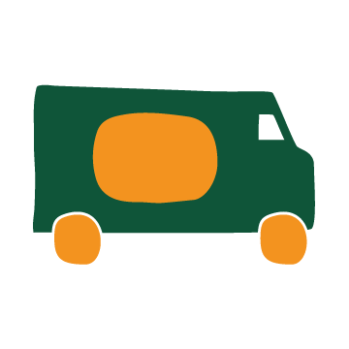
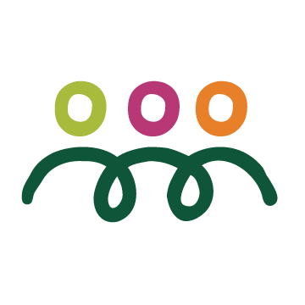

Community Needs
What identified community needs could our project address?

Student and Family Engagement
In what ways can we provide opportunities for students and families to inform our project?

Community engagement is “the process of working collaboratively with and through groups of people affiliated by geographic proximity, special interest, or similar situations to address issues affecting the wellbeing of those people”.​
How can I engage my community?

Support for Applicants: https://innovateschoolfood.org/support/
Questions I would like answered…

My next steps…

