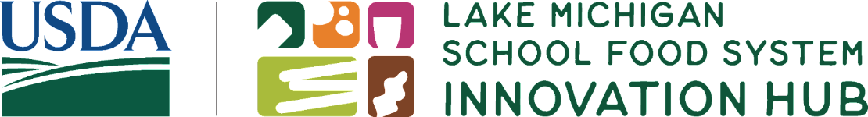
Innovation Hub Grants | Terms and Conditions
The Lake Michigan School Food System Innovation Hub is a project administered by the Illinois Public Health Institute with funding from the United States Department of Agriculture. As the pass-through entity, the Illinois Public Health Institute (IPHI) is responsible for ensuring that all awarded sub-grantees understand and comply with the award terms and conditions. Below is a partial list of the award terms and conditions. Relevant terms and conditions will be provided, upon request, during the sub-grantee award agreement process.
- All expenditures paid for with funds provided under this award must be incurred within the period authorized above, and be in accordance with the tasks, project deliverables, and guidelines outlined in the Award Terms and Conditions.
- Select and/or hire appropriately credentialed staff to manage and operate the project.
- Carry out all activities necessary to implement, operate, and evaluate the project as described in the approved project plan.
- Ensure use of the USDA logo has USDA approval and is in accordance with the USDA Style Guide at: https://www.usda.gov/style-guide/logo. [Note- IPHI will require sub-grantees to submit all documents that include the USDA logo to IPHI for review/approval by USDA]
- Provide reasonable accommodation and auxiliary aids and services for all webinars, videos, and other materials intended for the public, such as providing captioning services to enable participation for individuals with disabilities.
- Ensure appropriate non-discrimination (EEO statement) language is used on all websites and materials as directed and provided by USDA FNS.
- Provide to IPHI appropriate releases for all photographs, images, and other materials provided to IPHI giving IPHI and USDA unlimited rights to the use of the materials, including the right to redistribute, use and print items without restriction.
- Account for project funds separately from all other funds and establish financial and management reporting and controls to assure that project funds are not commingled or used inappropriately. A separate and distinct audit trail shall be established and maintained for the expenditure of project funds that clearly demonstrates that they are used solely for project purposes.
- Participate in at least one (1) site visit led by the Innovation Hub State Lead, which may include UDSA and/or IPHI.
- Provide quarterly progress reports to the State Leads and annual financial and progress reports to IPHI that describe all activities implemented and funded under this award.
- Entities must be registered in the System for Award Management (SAM).
- Sub-grantees shall make all records pertaining to activities under the grant available to IPHI for audit purposes.
- Unless otherwise advised by the Agency, the Sub-grantee will acknowledge the support of USDA FNS whenever publicizing the work under this grant.
- Other terms and conditions related to equipment, procurement, tangible personal property apply, and sub-grantees are expected to comply with Office of Management and Budget Guidance (OMB) via 2 CFR.

